Section 7-1: Geometric Means

SOL: None

Objective:
Find the geometric mean between two numbers
Solve problems involving relationships between parts of a right triangle and the altitude to its hypotenuse

Vocabulary:
Geometric Mean – between two numbers is the positive square root of their product
Arithmetic Mean – between two numbers is their average

Key Concept:
Geometric mean: for any positive numbers a and b, the geometric mean is positive x,

a x __
--- = --- or with cross products x² = ab or x = √ab
x b

Theorems:

Theorem 7.1: If the altitude is drawn from the vertex of the right angle of a right triangle to its hypotenuse, then the two triangles formed are similar to the given triangle and to each other.

Theorem 7.2: The measure of an altitude drawn from the vertex of the right angle of a right triangle to its hypotenuse is the geometric mean between the measures of the two segments of the hypotenuse.

Theorem 7.3: If the altitude is drawn from the vertex of the right angle of a right triangle to its hypotenuse, then the measure of a leg of the triangle is the geometric mean between the measures of the hypotenuse and the segment of the hypotenuse adjacent to that leg.

Example 1: Find the following:

Arithmetic Mean (AM): is the average of two numbers
example: 4 and 10

Geometric Mean (GM): is the square root of their product
example: 4 and 10

Example 2:

Find the AM and GM of the following numbers:
AM GM
a. 6 and 16

b. 4 and 8

c. 5 and 10

d. 2 and 14

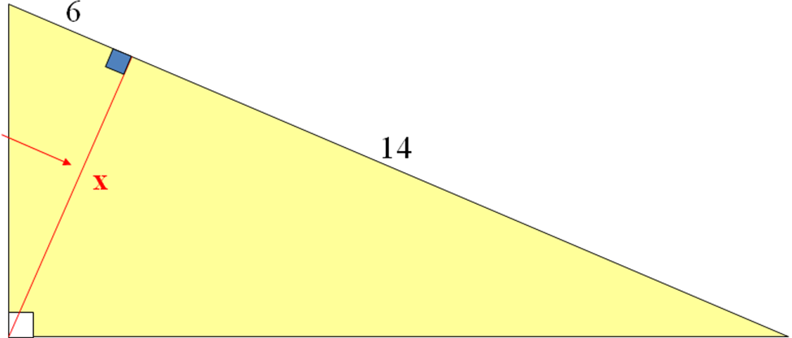
Example 3: Find the length, x, of the altitude:

Example 4: In ∆ABC, BD=6 and AD=17, find CD
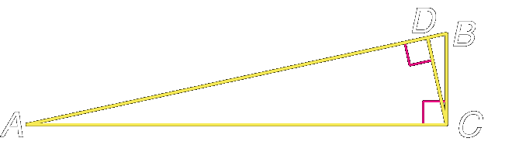

Example 5: Find c and d in ∆JKL
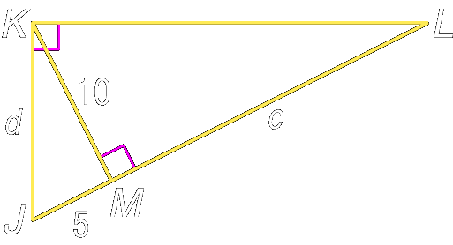

Concept Summary:
The geometric mean of two numbers is the square root of their product
You can use the geometric mean to find the altitude of a right triangle

Homework: pg 346, 10, 11, 13-15, 21-24, 29-31
Section 7-2: The Pythagorean Theorem and its Converse

SOL: G.7 The student will solve practical problems involving right triangles by using the Pythagorean Theorem, properties of special right triangles, and right triangle trigonometry. Solutions will be expressed in radical form or as decimal approximations.

Objective:
Use the Pythagorean Theorem
Use the converse of the Pythagorean Theorem

Vocabulary: None new

Theorems:

Theorem 7.4: Pythagorean Theorem: In a right triangle, the sum of the squares of the measures of the legs equals the square of the measure of the hypotenuse: a² + b² = c²

Theorem 7.5: Converse of the Pythagorean Theorem: If the sum of the squares of the measures of two sides of a triangle equals the square of the measure of the longest side, then the triangle is a right triangle

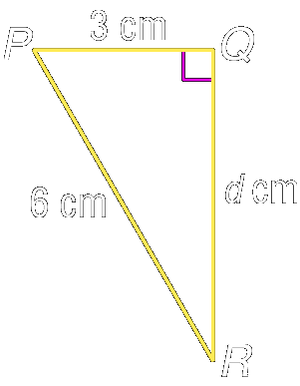
Example 1: Find QR in the figure to the right

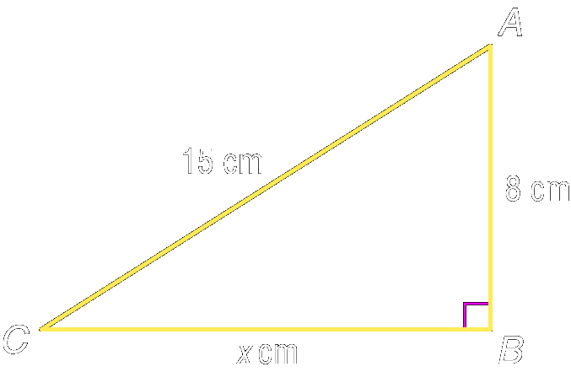

Example 2: Find BC in the figure to the left

Key Concept:
Pythagorean Triple: Three whole numbers that satisfy a² + b² = c²
Common examples: 3,4,5; 5,12,13; 6,8,10; 7,24,25, 8,15,17; 9,12,15; 9,40,41;

Example 3: Determine whether 9, 12, and 15 are the sides of a right triangle. Then state whether they form a Pythagorean triple.

Example 4: Determine whether 21, 42, and 54 are the sides of a right triangle. Then state whether they form a Pythagorean triple.

Example 5: Determine whether 4√3, 4, and 8 are the sides of a right triangle. Then state whether they form a Pythagorean triple.

Example 6: Determine whether each set of measures are the sides of a right triangle. Then state whether they form a Pythagorean triple.
- 6, 8, 10
- 5, 8, 9
- 3,√5, √14

Concept Summary:
The Pythagorean Theorem can be used to find the measures of the sides of a right triangle
If the measures of the sides of a triangle form a Pythagorean triple, then the triangle is a right triangle

Homework: pg 354, 17-19, 22-25, 30-35
Section 7-3: Special Right Triangles

SOL: G.7 The student will solve practical problems involving right triangles by using the Pythagorean Theorem, properties of special right triangles, and right triangle trigonometry. Solutions will be expressed in radical form or as decimal approximations.

Objective:
Use properties of 45°-45°-90° triangles
Use properties of 30°-60°-90° triangles

Vocabulary: None new

Theorems:

Theorem 7.6: In a 45°-45°-90° triangle, the length of the hypotenuse is √2 times the length of the leg.

Theorem 7.7: In a 30°-60°-90° triangle, the length of the hypotenuse is twice the length of the shortest leg, and the length of the longer leg is √3 times the length of the shorter leg.

Example 1: The wallpaper in the figure can be divided into four equal square quadrants so that each square contains 8 triangles. What is the area of one of the squares if the hypotenuse of each 45°-45°-90° triangle measures 7√2 millimeters?
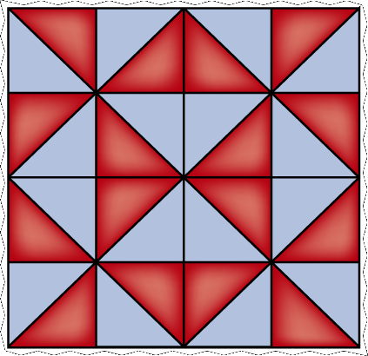

Example 2: If each 45°-45°-90° triangle in the figure has a hypotenuse of 5√2 millimeters, what is the perimeter of the entire square?

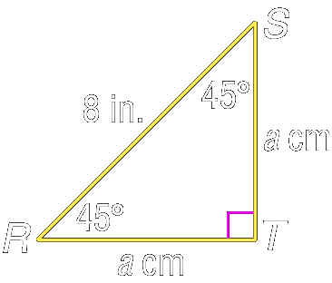
Example 3: Find a in ∆RST

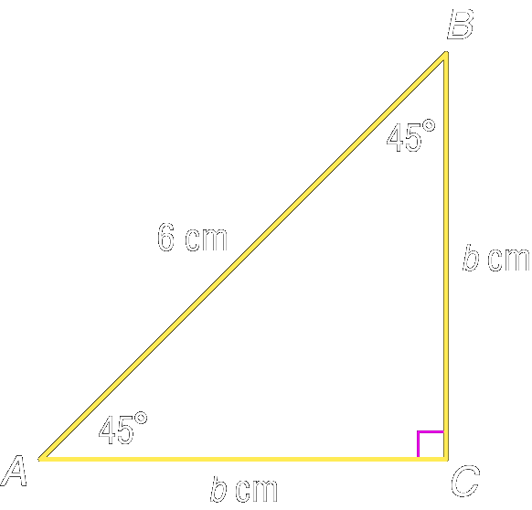
Example 4: Find b in ∆ABC

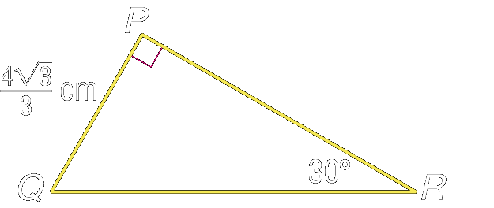
Example 5: Find QR in ∆PQR

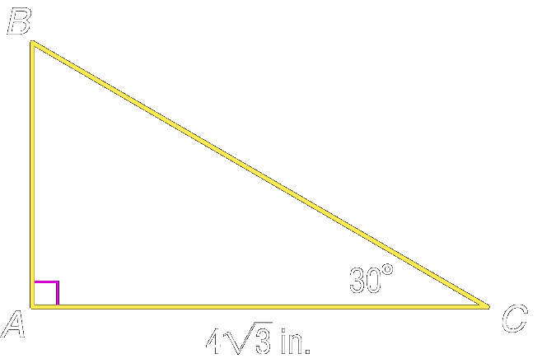
Example 6: Find BC in ∆ABC

Concept Summary:
In a 45°-45°-90° triangle, the hypotenuse is √2 times the length of the leg. The measures are x, x, and x√2
In a 30°-60°-90° triangle, the measures of the sides are x, x√3, and 2x.

Homework: pg 360, 4-6, 12-17, 21-23
Section 7-4: Trigonometry

SOL: G.7 The student will solve practical problems involving right triangles by using the Pythagorean Theorem, properties of special right triangles, and right triangle trigonometry. Solutions will be expressed in radical form or as decimal approximations.

Objective:
Find trigonometric ratios using right triangles
Solve problems using trigonometric ratios

Vocabulary:
Trigonometry (or Trig) – involves triangle angular measurement
Inverses, (trig function ⁻¹), finds the angular measurement

Key Concept:

Trig  Function | Definition | Common Angles
Trig  Function | Definition | 0° | 30° | 45° | 60° | 90°
Sin | Opposite over Hypotenuse | 0 | ½  0.500 | √2/2  0.707 | √3/2  0.866 | 1
Cos | Adjacent over Hypotenuse | 1 | √3/2  0.866 | √2/2  0.707 | ½  0.500 | 0
Tan | Opposite over Adjacent | 0 | √3/3  0.577 | 1 | √3  1.732 | ∞
SOH-CAH-TOA (Sin∠= O/H, Cos∠= A/H, Tan∠= O/A)

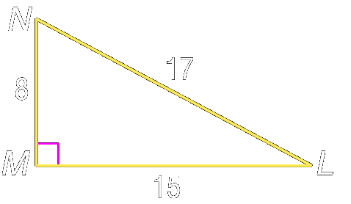
Example 1: Find sin L, cos L, tan L, sin N, cos N, and tan N. Express each ratio as a fraction and as a decimal

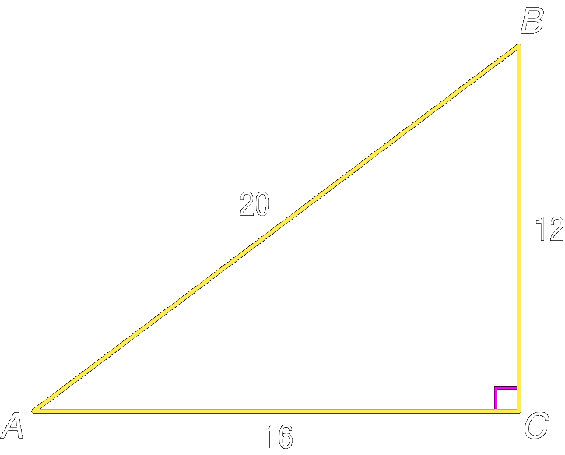

Example 2: Find sin A, cos A, tan A, sin B, cos B, and tan B. Express each ratio as a fraction and as a decimal.

Example 3: Use your calculator to find (to the nearest ten thousandth)

- tan 56° =
- cos 90° =
- sin 48° =
- cos 85° =
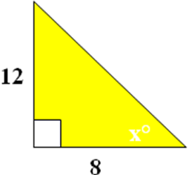
Day Two
Example 1: Find the angle

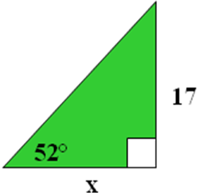
Example 2: Find the side

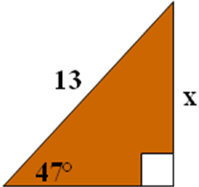
Example 3: Find the side

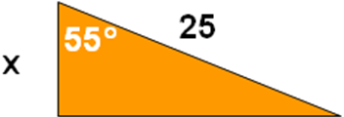
Example 4: Check Yourself:
- You have a hypotenuse and an adjacent side
Use: _______ Solve: x = ___

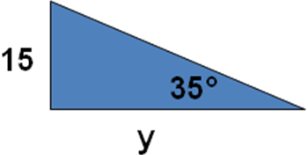
- You have an opposite and adjacent side
Use: _______ Solve: y = ___

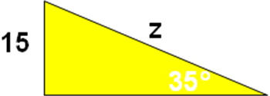
- You have an opposite side and a hypotenuse
Use: _______ Solve: z = ___

Example 5: A fitness trainer sets the incline on a treadmill to 7°. The walking surface is 5 feet long. Approximately how many inches did the trainer raise the end of the treadmill from the floor?

Example 6: The bottom of a handicap ramp is 15 feet from the entrance of a building. If the angle of the ramp is about 4.8°, how high does the ramp rise off the ground to the nearest inch?

Concept Summary:
Trigonometric ratios can be used to find measures in right triangles

Homework: Day 1: pg 367-368; 1, 4, 5-8, 11, 15, 16
Day 2: pg 368, 18-21, 43-46, 61
Section 7-5: Angle of Elevation and Depression

SOL: G.7 The student will solve practical problems involving right triangles by using the Pythagorean Theorem, properties of special right triangles, and right triangle trigonometry. Solutions will be expressed in radical form or as decimal approximations.

Objective:
Solve problems involving angles of elevation
Solve problems involving angles of depression

Vocabulary:
Angle of elevation: angle between line of sight (looking up) and the horizontal
Angle of depression: angle between line of sight (looking down) and the horizontal

Example 1: Before the Mast -- At a point on the ground 50 feet from the foot of the flagpole, the angle of elevation to the top of the pole is 53°. Find the height of the flagpole.

Example 2: Job Site -- A 20-foot ladder leans against a wall so that the base of the ladder is 8 feet from the base of the building. What angle does the ladder make with the ground?

Example 3: CIRCUS ACTS -- At the circus, a person in the audience watches the high-wire routine. A 5-foot-6-inch tall acrobat is standing on a platform that is 25 feet off the ground. How far is the audience member from the base of the platform, if the angle of elevation from the audience member’s line of sight to the acrobat is 27°?

Example 4: The angle of elevation from point A to the top of the press box is 49°. If point A is 400 ft from the base of the press box, how high is the press box?

Example 5: Find the angle of elevation of the sun when a 12.5 ft post casts a 18 ft shadow?

Example 6: A ladder leaning up against a barn makes an angle of 78° with the ground when the ladder is 5 feet from the barn. How long is the ladder?

Example 7: From the top of the 120 foot fire tower a ranger observes a fire at an angle of depression of 19°. How far from the base of the tower is the fire?

Example 8: A hill is 1000 yards long with a vertical drop of 208 yards. Find the angle of depression from the top of the hill to the bottom.

Concept Summary:
Trigonometry can be used to solve problems related to angles of elevation and depression

Homework: 5, 6, 8, 9, 17-19
Section 7-6: Law of Sines

SOL: None.

Objective:
Use the Law of Sines to solve triangles
Solve problems by using the Law of Sines

Vocabulary:
Solving a triangle – means finding the measures of all sides and all angles

Key Concept:
Law of Sines can be used to find missing parts of triangles that are not right triangles

Case 1: You know the measures of two angles and any side of the triangle (AAS or ASA)
Case 2: You know the measures of two sides and an angle opposite one of the known sides of the triangle (SSA)

Concept Summary:
To solve a triangle means to find the measures of all sides and angles
To find the measures of a triangle by using the Law of Sines, you must either know the measures of two angle and any side (AAS or ASA), or two sides and an angle opposite one of these sides (SSA) of the triangle

Homework: pg 380-381; 1, 4-7, 17-21, 30, 32

Section 7-7: Law of Cosines

SOL: None.

Objective:
Use the Law of Cosines to solve triangles
Solve problems by using the Law of Cosines

Vocabulary: None new

Key Concept:
Law of Cosines can be used to solve triangles when the Law of Sines cannot be used

Case 1: You know the measures of two sides and their included angle (SAS)
Case 2: You know the measures of all three sides (SSS)

Concept Summary:
The Law of Cosines can be used to solve triangles when you know the measures of two sides and the included angle (SAS) or the measures of all three sides (SSS)

Homework: pg 388-389; 11, 12, 19-21, 27-30, 42

Decision Tree for Trig Problems
Right Triangle |  |  | Unknown Triangle
Special Triangles |  |  | Use Law of Sines or Law of Cosines
45-45-90 | 30-60-90 |  | Rule | Known
 |  |  | Law of  Sines | Measures of two angles and any side  (AAS or ASA)
Non-Special Triangles |  |  | Law of  Sines | Measures of two sides and an angle opposite one of these sides (SSA)
Use regular sin, cos, and tan |  |  | Law of  Cosines | Measures of two sides and the included angle (SAS)
 |  |  | Law of  Cosines | Measure of all three sides (SSS)

Use inverses to find angular measurement

We will revisit trig functions when we get into circles (Chapter 10).

For some interesting JAVA applets on trigonometry:

Sine and cosine: http://www.catcode.com/trig/trig05.html

Tangent: http://www.catcode.com/trig/trig12.html

Circles: http://www.catcode.com/trig/trig06.html

Lesson 7-1:

Find the geometric mean between each pair of numbers. State exact answers and answers to the nearest tenth.
- 9 and 13 2. 2√5 and 5√5

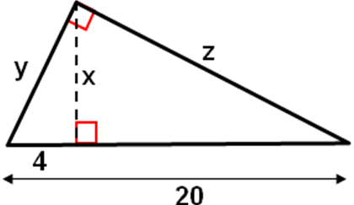

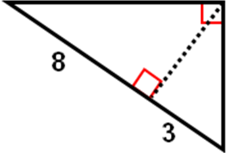
3. Find the altitude 4. Find x, y, and z

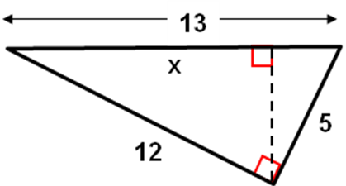
5. Which of the following is the best estimate of x?

Lesson 7-2:
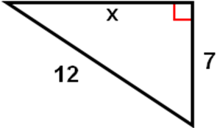
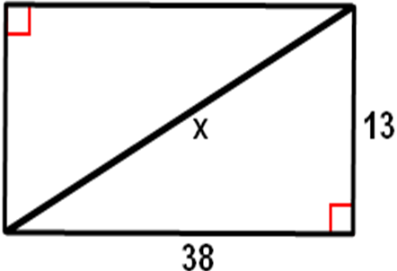
Find x.
- 2.

3. Determine whether ∆QRS with vertices Q(2,-3), R(0,-1), and S(4,-1) is a right triangle. If so, identify the right angle.

Determine whether each set of measures forms a right triangle and state whether they form a Pythagorean triple.

4. 16, 30, 33 5. 5/8, 3/2, 13/8

6. Which of the following are not the lengths of sides of a right triangle?
a. 25, 20, 15 b. 4, 7.5, 8.5 c. 0.7, 2.4, 2.5 d. 36, 48, 62

Lesson 7-3:
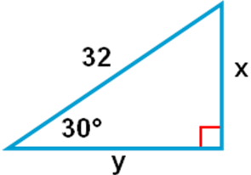
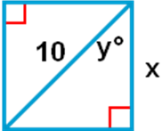
Find x and y.
- 2.

3. The length of a diagonal of a square is 15√2 cm. Find the perimeter of the square.

4. The side of an equilateral triangle measures 21 inches. Find the length of the altitude of the triangle.

5. ∆MNP is a 45°- 45°- 90° triangle with right angle P. Find the coordinates of M in quadrant II with P(2,3) and N(2,8).
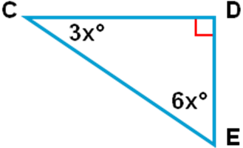

6. In the right triangle find CD if DE = 5.?

Lesson 7-4a:
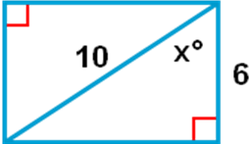
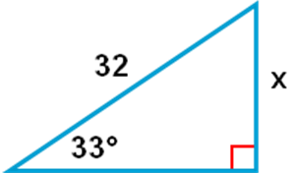
Find x.
- 2.

3. Given an adjacent side and the hypotenuse, which trig function do you use?

4. Given an opposite side and the hypotenuse, which trig function do you use?

5. ∆MNP is a 45°- 45°- 90° triangle with right angle P. Find NP if MN = 20.

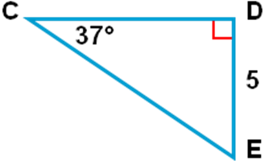
6. In the right triangle which trig function would you use to find CD with ∠C?
a. sin b. cos c. tan d. sec

Lesson 7-4b:

1. Use a graphing calculator to find tan 54°. Round to the nearest ten-thousandth.
2. Find m∠B to the nearest tenth of a degree if cos B = 0.8926 and ∠B is an acute angle.

Find x. Round the nearest tenth.
3. 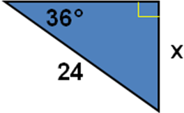 4. 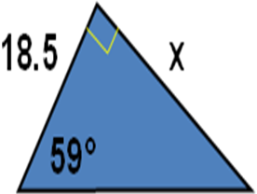 5. 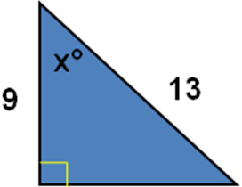
6. What is the value of tan Θ? 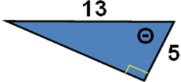
a. 12/5 b. 12/13 c. 5/12 d. 5/13

Lesson 7-5:

Name the angles of depression and elevation in the two figures.
- 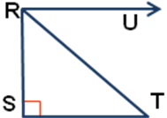 2. 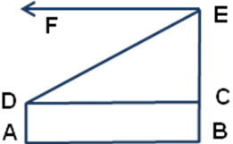
3. Find the angle of elevation of the sun when a 6-meter flag pole casts a 17-meter shadow.
4. After flying at an altitude of 575 meters, a helicopter starts to descend when its ground distance from the landing pad is 13.5 Km. What is the angle of depression for this part of the flight?
5. The top of a signal tower is 250 feet above sea level. The angle of depression for the tope of the tower to a passing ship is 19°. How far is the foot of the tower from the ship?
6. From a point 50 feet from the base of a tree, the angle of elevation to the top of the tree is 32°. From a point closer to the base of the tree, the angle of elevation is 64°. Which of the following is the best estimate of the distance between the two points at which the angle of elevation is measured?
a. 15 b. 28 c. 29 d. 35

